Differential Equations Test 1 Name _________________
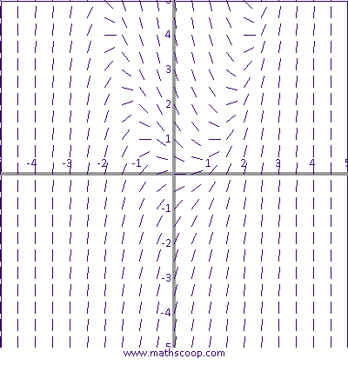
Work each of the following problems analytically on the blank paper provided. Show all work in a neat, orderly manner. No credit will be given for answers without the work involved in arriving at the answer.
1. On the graph shown, sketch an appropriate solution curve that passes through each of the indicated points. Label each sketch with the letter of the point.
A) y(0) = 1
B) y(0) = -2

2. A) Show that y = ln(x) + c is a solution to the DE xy” + y’ = 0 on the interval (0, ∞).
B) Given the general solution in part A, find the solution to the initial-value problem consisting of the given DE and the initial condition y(2) = 4.

3. Find c₁ and c₂ so that y(x) = c₁ sin(x) + c₂ cos(x) will satisfy the conditions y(0) = 1 and
y’(π) = 4.

4. Consider the DE: $\frac{dy}{dx}=$ y(y - 6)(y + 1)²
A) Construct a phase portrait for the differential equation.
B) Classify the critical points as stable, semi-stable, or unstable.

5. Use separation of variables to solve the initial value problem:
$\frac{dy}{dx}=\frac{e^{3x}+x}{y^{2}}$ ; y(0) = 5

6. Show that the DE is exact, and use the method of exact DE’s to solve.
(cos(y)+e^{x})dx – (x sin(y))dy = 0
7. Find the appropriate integrating factor to make the DE exact. Verify that the integrating factor makes equation exact. You do not need to solve the DE.
xy dx + (2x² + 3y² – 1)dy = 0

8. Use the method of solving linear DEs to solve the DE: $x^{2}\frac{dy}{dx}-y=x^{2}e^{-1/x}$
Give your final answer in the form y equals a function of x.

9. Given the DE $\frac{dy}{dx}= \frac{y^{2}+xy}{x^{2}}$, show that it is homogeneous and solve.

10. A cup of tea is initially 180 degrees and is left in a room with an ambient temperature of 75 degrees. Seven minutes after the tea is left in the room, the temperature of the tea is 100 degrees. Suppose the rate of cooling is proportional to the difference between the temperature at time t and the ambient temperature.
A) Write the differential equation and conditions.
B) Find the solution to the differential equation including the value of the constant k.

11. A 100-gallon tank contains brine made by dissolving 40 pounds of salt in water. A brine solution containing 2 pounds per gallon of salt enters the tank at a rate of 2 gallons per minute; the well-stirred mixture is pumped out at a rate of 4 gallons per minute.
A) Set-up a differential equation for the amount of salt in the tank after t minutes. Also, give the initial condition.
B) Solve the differential equation.

12. What constant interest rate is required if an initial deposit placed into an account that accrues interest compounded continuously is to double its value in ten years? The DE is $\frac{dA}{dt}=rA$ where r is the interest rate. Solve the DE and answer the question.

